PROJECT PROPOSAL
PART-A
1.0 | Title of the Project: | Design and Development of Open Source Platform for AIISH Digital Repository and Online Public Access Catalogue
 | Area of Research: | Others
1.1 | Principal Investigator | Dr.Shijith Kumar C
1.2 | Principal Co-investigators | Mr. Nanjunda Swamy, M.,  Mr. Nidheesh David Kuruvila,  Mr. Lokesh, P
1.3 | Collaborating Institution | Nil
1.4 | Total Grants required | Rs. 3 lakhs
1.5 | Duration of the Project | 12 months

- Project Summary
The All India Institute of Speech and Hearing is one of the early implementers of the Institutional Repository (IR) and Integrated Library Management System (ILMS) among the higher educational Institutions in the country. However, both the solutions were developed on proprietary software platforms with limited functionalities and are being continued even today without any further modification or addition of features. On the other hand, the IR and ILMS fields at present are dominated by freely available open source applications with advanced features and functionalities. This project proposes to design and develop an open source based platform for the Institute IR and Online Public Access Catalogue and migration of the existing collection of resources to the new platform. The new platform will have provision for incorporating a wide range of Institutional resources such as official photographs, videos, teaching learning materials and question papers in addition to the existing postgraduate, doctoral and funded research projects. It is expected to provide advanced research repository service for the user community and facilitate better visibility for the research output of the Institute at global level.
- Introduction
Institutional Repository (IR) also known as digital repository or digital library is a solution for gathering, preserving and disseminating intellectual output of an educational and research organization, and Online Public Access Catalogue (OPAC) is a tool for preserving and retrieving the bibliographic elements of its collection of information resources. The availability of user-friendly software applications and increase in the I.T. literate information user community have made IRs and OPACs a common place in educational institutions across the world.
3.1 Definition of the Problem
All India Institute of Speech and Hearing (AIISH), the premier institution in the country in the field of communication disorders launched its IR in the year 2009 and introduced the full version of OPAC by installing an Integrated Library management System (ILMS) in 2011. Both the applications were developed by third party using proprietary software tools. Presently, the repository contains more than 1700 records consisting of postgraduate and doctoral dissertations, and the funded research project reports. The OPAC contains the bibliographic records of 20,000 plus print collection of the Institute library. Both the IR and OPAC are being maintained on payment basis by the third parties who developed them.
Our working experience with the applications and the feedback we have been receiving from our user community strongly suggest a thorough modification in the functionalities and upgradation of both the digital repository and OPAC. However, upgradation and modification processes require additional expenses from the part of the Institute as the applications are running on proprietary software developed by third parties and getting it done by making payment is not feasible considering the fact that the upgradation may be needed frequently. On the other hand, there are plenty of free open source applications for building digital repository and OPAC with advanced features and functionalities. Upgradation is also free on these software. Hence, this project proposes to design and develop an open source platform for the digital repository and OPAC and migration of the existing digital repository collection and the OPAC bibliographic records to the new system.
3.2 Objectives of the Project
The objectives of the project are the following.
- To systematically evaluate and summarize the drawbacks of the existing IR and OPAC of AIISH.
- To identify suitable open source software alternatives for the existing IR and OPAC.
- To design and develop a open source platform and migration of the resources
- To expand and enrich the content base of the repository by additionally incorporating the following resources.
- Official photographs and videos of the Institute
- Teaching learning materials including presentations and guest lectures
- Question papers
- Syllabus
- Any other materials produced at the Institute related to education and research
- To facilitate content based searching of digital repository and discoverability on search engines.
- To generate a new comprehensive set of metadata for the IR and OPAC as per the international standards
- To facilitate interoperability for the IR with the related institutional and national repositories across the world.
3.3 Current international and national status of Institutional Repositories and Online Public Access Catalogues
There has been a proliferation in the number of IRs and OPACs both internationally and nationally in the last few years with the emergence of Open Source Software solutions in the field. According to the Ranking Web of Repositories¹, totally there are 2297 no. of IRs all over the world and in India there are 43 repositories. These repositories differ greatly in content, size, scope and objectives and majority of the IRs operating in India are open source based ². Two active national repositories in India at present are Sodhganaga³, a repository of Indian doctoral theses and Sodhagangotri ⁴, a repository of Indian doctoral research in progress, both developed by the INFLIBNET, a constituent of UGC, Govt. of India. The National Digital Library ⁵ is a new repository from India developed at the IIT, Kharagpur as a part of the National Mission on Education through Information and Communication Technology of the Ministry of Human Resource Development, Govt. of India.
3.4 Importance of the Present Project
A review of the current international and national status of the subject reveals the importance of developing Institutional Repositories. Also, majority of the repositories that have been developed in India are on open source platform and they have a lot of features and functionalities such as content based searching, e-mail alerts, interoperability with other IRs, web search engine discoverability, etc. which AIISH digital repository does not have. Hence, it is imperative to develop a repository for the Institute on open source platform for the benefit of its user community.
4.0 Work Plan
4.1 Materials and Methods
The following step by step methodology will adopted for the study.
- Analyzing the performance of the existing IR and OPAC based on a set of criteria and listing the drawbacks.
- Identification and selection of suitable open source alternatives by means of surveying the literature, evaluation and testing.
- Rectification of content errors of the existing digital collection manually as well as with the help of software applications such as Abby Fine Reader
- Conversion of the digital collection from the image format to searchable pdf
- Choosing appropriate metadata with the help of Doublin Core Metadata Standard
- Design and development of new platforms using the selected software applications
- Migration of the digital collection and bibliographic records to the new platform
- Trial running
- Finalization of the system
4.2 Hardware and Software system requirement
- Computer with Intel Core-i 3 or later processor, 4 GB RAM and 2 TB storage capacity
- Open source software for building Institutional Repository and Integrated Library Management System
- Apache
- MySQL
- Ubuntu-Linux Operating System
- PHP
4.3 Time Schedule
Sl.  No. | Activity | Required Time
Sl.  No. | Activity | In Weeks | In Months
 | Overall duration of the Project | 52 | 12
 | Evaluation of the existing system | 4 | 1
 | Identification, selection, evaluation and testing of open source software applications | 8 | 2
 | Software customization, interface design, programming/coding | 32 | 8
 | Checking of the existing digital collection for errors and missing of pages | 20 | 5
 | Creation of metadata elements | 24 | 6
 | System trial running and finalization | 8 | 2
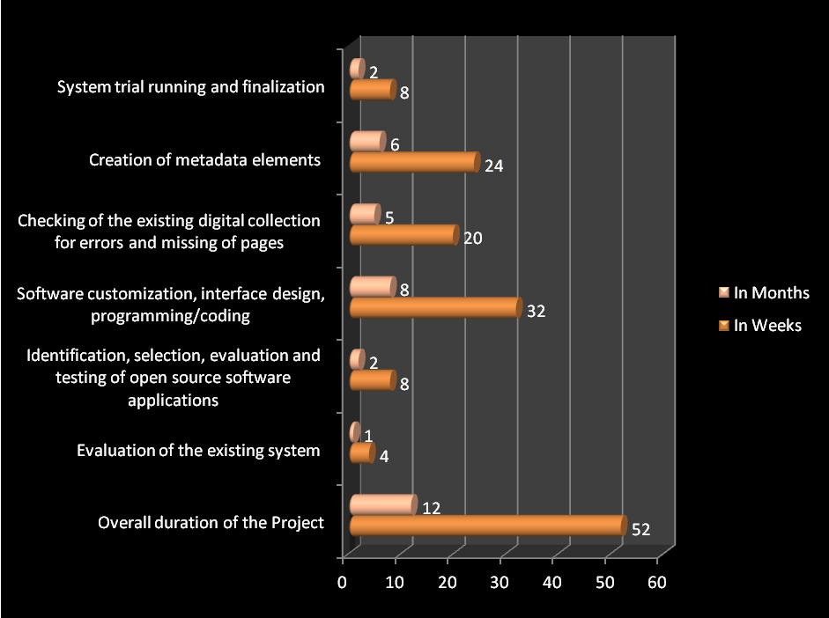
- Budget Summary
SNo. | Item | Expenditure  (Rs.)
1 | Salary for Research Officer  No. of posts: One  Qualifications: M.L.I.Sc.  Salary: (Rs.25000 x 12 months)  Justification: A fulltime research officer with Master’s degree in Library Science is required for the project to create and upload metadata for the 20,000 plus records | 3.00 lakhs
2. | Consumables | Nil
3 | Travel | Nil
4. | Other Costs | Nil
 | Total | - lakhs

- Implications of the Study
The present project is expected to have the following implications:
- Save the annual maintenance charge for the IR
- Facilitate more visibility for the research output of the AIISH globally
- Facilitate future upgradation of the AIISH repository to a National Repository on Communication Disorders
- Facilitate future development of an online union catalogue on communication disorders
- Help in promoting the development and sharing of digital teaching and learning materials in the area of communication disorders
- Help other Institutions in planning and implementing new repositories and OPAC
- Serve as a model for the Institutions who are planning for migrating from proprietary to open source based repository and OPAC.
- Utilization of the Study
The existing institutional repository and OPAC of the Institute in use will be replaced by the new system after getting the necessary approval
8.0 Roles and Responsibilities
SNo. | Investigator | Roles and Responsibilities | Signature
1 | Dr. Shijith Kumar C | Overall supervision and coordination, Report writing, Presentation, evaluation of the performance of the existing system, designing of new system, development of workflow, interacting with open source community.
2. | Mr. Nanjunda Swamy, M | Evaluation of the performance of the existing system, Identification of suitable open source software and testing, System development, Error detection, trial running.
3 | Mr. Nidheesh David Kuruvila | Checking all the reports (1700 nos.) and replacing the missing pages by scanning from the print reports.  Correcting errors in the content with the help of JRFs.  Uploading of reports to the new platform (shared role)
4 | Mr. Lokesh P | Conversion of the reports from image formats to searchable pdf .  Metadata creation for all the reports in the repository.  Uploading of reports to the new platform (shared role).
5 | Research Officer | Creation of metadata for bibliographic records of the print collection (20,000 plus records)

References
- Cybermetrics Lab (2016). Ranking Web of Repositories. Retrieved June 19, 2016 from http://repositories.webometrics.info/en.
- Gohain Rashmi Rekha (2011). Current trend and development of institutional repositories in India. International Journal of Information Research, 1 ,1.
- Shodhganga: A reservoir of Indian theses @ INFLIBNET. (n.d.). Retrieved June 20, 2016, from http://shodhganga.inflibnet.ac.in/
- Shodhgangotri: Repository of Indian Research in Progress @ INFLIBNET. (n.d.). Retrieved June 20, 2016, from http://shodhgangotri.inflibnet.ac.in/
- National Digital Library (NDL). Retrieved June 19, 2016, from http://ndl.iitkgp.ac.in/

