PROJECT PROPOSAL
Part -A
1.0 | Title of the Project: |  | Development of a test battery for assessing recall ability
11.3.3 | Area of Research :  - Speech, Language, Hearing  - Clinical Psychology  - Special Education  - ENT  - Electronics  - Interdisciplinary  - Survey  - Socio-Economic  - Others |  | - Speech, Language & Hearing.
1.1 | Principal Investigator: |  | Dr.Abhishek.B.P
1.2 | Co-Investigator(s): |  | Dr.Yeshoda.K
1.4 | Institution : |  | AIISH
1.5 | Total Grants Required : (in figures and in words) |  | Rupees 5,00,000 (Five Lakh Rupees only)
1.6 | Duration of the Project: 12 months

2.0 Project Summary-. Recall is known to be an important substrate of memory. It is a part of neuro psychological test batteries also. Some of the test batteries configured for Indian scenario also incorporates recall (ex Cognitive linguistic assessment protocol developed by Anuroopa & Shyamala, 2006). However the segment on recall may not give a comprehensive picture about recall, its variants and its trend across aging. The present study aims at developing a test battery for recall abilities. A previous study has been carried in this direction by Veena and Abhishek (2016). The study tested recall on younger group (between 18-25 years) and older group (between 55-65 years). It was reported that the older group has poor recall abilities compared to the younger group However the study used representative sample. It did not incorporate the middle age group especially people between the age range of 35-55 years. The present study involves standardization of the test material used in the previous study and also field testing it on a group 100 individuals (20 each in the age range of 20-30 years, 30-40 years, 40-50 years, 50-60 years, and 60-70 years)

Definition of the problem- The issue of memory loss has always been a common concern among aging adults. As age increases there is high chance that there could also be deterioration in memory and other cognitive skills; therefore, the growth of the population of elderly individuals indicates the need to understand age-related memory changes. This will help us to differentiate between senile and senescent changes in older individuals. The close association between recall and language processing indicates the need to develop assessment and treatment methods that address both language and recall abilities. It is also essential by speech and language pathologists to understand ways in which different types of recall abilities support language functions and how impairment in these specific functions can affect communication abilities.

Background: Recall and Recognition are two terms that we come across when we discuss about different processes of information processing or memory. Recognition is the relationship between an event and a physical object, with one, that has been previously experienced or encountered, and it involves a process of comparison of information with memory. Recognition is an unconscious or a passive process. When the previously encountered event is re -experienced, the current environmental content is matched to the already stored memory traces, and thus eliciting matching signals.

Human long-term memory consists of traces of many thousands of words, pictures, episodes, and other types of information and hence retrieving/recalling this information is challenging. Due to these factors recent research has been considerably into the final stage of memory process that is recall. Recall in memory implies the subsequent re-accessing of events or information from the past, which have been previously encoded and stored in the brain. It is one of the three core processes of memory along with encoding and storage. It involves remembering a fact, event or object that is not currently physically present and requires the revealing of information from memory. Recall is an active process, i.e.; it can be recollected or retrieved from storage at will. Several models have been put forth to describe the process of recall. One such model is the Generate-Recognize model given by (Kintsch, 1970). According to this model, it is assumed that during the process of recall, an item is retrieved from memory by the search process first, and then the respective item is tested by the recognition process to determine if it is from the to-be-recalled list. Thus, in order for a word to be recalled it must both be successfully retrieved and recognized. Another explanation is based on the Encoding Specificity principle by Tulving and Thompson in 1976 which states that memory uses information from the memory trace, or the context in which it was learned, and from the environment in which it is retrieved, i.e.; memory is improved when information available at encoding is also available at retrieval. Encoding specificity takes into account the effect of context cues.

Types of recall: There are five main types of recall; free recall, cued recall, serial recall, delayed recall and immediate recall.
- Free recall: This involves asking individuals to recall a list of items in any order.
- Cued recall: Cues act as guides to what the person is supposed to remember. A cue can be virtually anything that may act as a reminder, e.g. a smell, song, color, place.
- Serial recall: It refers to our ability to recall items or events in the order in which they occurred.
- Immediate recall: It refers to the temporary storage of information for a few seconds to hours. Otherwise refers to short term memory.
- Delayed recall: Ability to recall a piece of information in a given period of time after it was learnt.

Language and Recall- Cognition plays an important role in language and communication. Language comprehension and formulation are part of the cognitive system. Difficulty in recalling is the most vexing problem human beings face. Lewis, Vasishth and Van Dyke (2006) describe a computational model of sentence processing which emphasizes that recall is necessary for accurate sentence processing. Repetitive transcranial magentic stimulation investigations have provided evidence that the left inferior frontal gyrus has a role in successful inference resolution (Feredoes, Tononi, & Postle, 2006). This region also includes Broca's area which is associated with language functions especially syntactic processing (Rogalsky & Hickock, 2010). Evidence from research in Aphasia suggests that there is close association between word processing and verbal short term memory (Saffran & Martin, 1990). Linguistic contexts also influence recall in a number of different ways. The language spoken helps to create the external context (Smith, 1988); language in which the mental activities are carried out creates the internal context (Bower, 1981). Finally, mental reinstatement of the language used on an earlier occasion may help to produce increased recall just as mental reinstatement of context does (Geiselman, 1988). Language-dependent recall combines features from each of these phenomena (Marian & Neisser, 2000).

Recall in Pathological population- Memory problems are associated with many psychiatric and neurological illnesses. Recall abilities are affected in many neurological disorders. Often recall is used as a measure to diagnose and differentially diagnose several neurological disorders. This also helps in early identification of disorders like Alzheimer's, Dementia and to track the progress of the disorder. Patients diagnosed with amnesia show a recency effect but they have poor ability to retain primacy items (Carlesimo, Marfia, Loasses, & Caltagirone, 1996). Patients with anterior temporal lobe resections show significant difficulty in recall from primary and middle portions of a word list, but have the recency portion preserved, compared with preoperative performance (Hermann, et al., 1996). The lack of a primacy effect is one of the most defining features of word-list learning in patients with Alzheimer disease (Carlesimo, Fadda, Sabbadini, & Caltagirone, 1996). Foldi and her colleagues (Foldi, Brickman, Schaefer, & Knutelska, 2003) compared recall total across five trials of primacy and middle regions of the list with items in the recency region. The controls recalled the primacy and recency regions equally, while the AD group recalled recency > middle > primacy. The mild and very mild AD patients had a recency effect but no primacy effect (Bayley, et al., 2000). Gainotti and colleagues (Gainotti, Marra, Villa, Parlato, & Chiarotti, 1998) also reported similar findings. They report that it is because of difficulty in consolidating information into long term memory.

Aging and Recall- A major concern for older adults is that they will experience memory loss as they age (Johnson & Halpern, 1999). Aging is accompanied by a general slowing in cognitive processing that appears to include all components of processing (e.g., Birren, Woods, & Williams, 1980; Cerella, 1985). It is well known that age interact with memory performance. Among the memory processes recall is affected the most. Miller, 1956 pointed out that younger adults had better recall abilities than older adults. Baddeley, Thomson, and Buchanan (1975) reported that the accuracy of recall depends upon the number of items that an individual could recite in about 2 s, and subsequent work by Kynette, Kemper, Norman, & Cheung, 1990 indicated that the recitation rate slowed with aging. Certain authors argue that this is because of the limitation in the capacity to hold information and others argue it to be due to difficulties in the process of chunking information. Aging adults form weaker item-to-item associations than young adults and this leaves the older adults less able to use these associations to form multi-item chunks in serial recall. Aging adults often produce serial position functions different from those produced by young adults (Maylor, Vousden, & Brown, 1999; Murphy, Craik, Li, & Schneider, 2000). Chalfonte & Johnson (1996) and Mitchell, Johnson, Raye, Mather & D’Esposito (2000) showed that older adults are particularly deficient in memory that requires the binding of information to contextual elements. According to Salthouse (1996b) age differences in memory do not reflect changes in memory processing per se, but instead merely reflect age differences in the speed of processing.

  - International status- Many retrospective studies have been carried out to tap recall abilities in neuro typical and pathological population, most of the studies carried out in this direction have tried to study one or more variants of recall or the effect of one or several variables influencing recall. Studies on the consequence of aging on recall abilities have also been carried out. The present study tends to incorporate all this into a single study in order to derive comprehensive picture on recall abilities. It also attempts in developing a test battery for testing recall abilities

  - National status: Many tests like Cognitive linguistic assessment protocol (Kamath & Prema, 2000) and cognitive linguistic quick test (Vandana & Shyamala, 2010) assesses various cognitive linguistic processes. The former uses recall and latter uses list generation. Recall imposes certain amount of constraint on the recall and the recall abilities tends to decline with the processes of aging . Even in the clinical population like mild cognitive impairment or dementia recall is the first cognitive linguistic process to show decline. An earlier study by Veena and Abhishek (2016) tried to study recall in two representative groups 18-25 years and 55-65 years. It was reported that recall abilities declined with age, the pattern of decline, the onset of decline, the effect of aging on the different types of recall was not reported in this study. The present study aims to develop a test battery for recall and also decipher information on the variables listed above,

4.0 Work Plan

Participants- The present study involves standardization of the test material used in the previous study and also field testing it on a group 100 individuals (20 each in the age range of 20-30 years, 30-40 years, 50-60 years, 60-70 years and 70-80 years). Within each group both males and females will be considered. Participants will be screened with Mini Mental State Examination MMSE (Folstein, Folstein & McHugh, 1975) to rule out pre-existing memory disturbances if any. General health of the participants will be assessed through the Patient Health Questionnaire abbreviated as PHQ-9 ( Bower, 2002) to rule out any sensory or neurological deficits. PHQ is a client oriented questionnaire and can be filled by participant himself/herself. The socioeconomic status, occupation etc will be documented by employing NIHMS scale (Venkatesan, 2006).

Stimuli selection- The test material used will be same as the previous study by Veena and Abhishek (2016). Stimulus used in this study was derived from the following standardized test materials indicated below
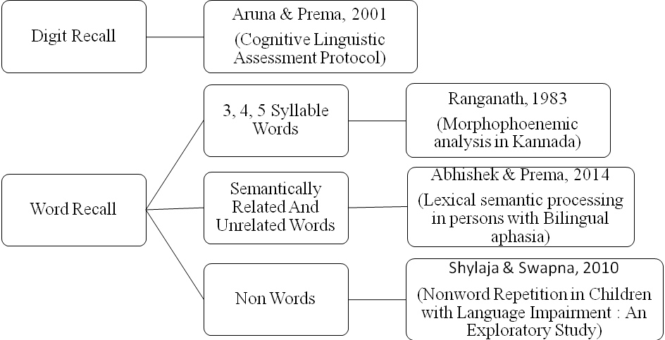

Procedure- The mode of presentation of the stimulus will be in auditory mode. A string of ten units will be presented one after the other, each with an inter stimulus duration of 1seconds. The stimulus will be prepared and presented through Adobe Audition software.
The testing will be carried out in 4 conditions for all the participants. The four conditions included
- Immediate free recall
- Immediate serial recall
- Delayed free recall
- Delayed serial recall.
In the immediate free recall condition, participants will be instructed to recall the units immediately after the presentation of the stimulus in any order of presentation of stimulus, where as in the immediate serial recall condition, participants will be instructed to recall, in the order of presentation of the stimulus. In contrast, in the delayed free recall condition, participants will be instructed to recall the units after a delay of 10 seconds in any order of presentation and in delayed serial recall, they will be instructed to recall after the delay of 6 seconds but in the same order of presentation of stimulus. During the delay of 10 seconds, participants will be made to repeat the number 1234 verbally to prevent rehearsal of the stimulus. Reciting numbers to prevent rehearsal will be used for the word recall tasks and for the digit recall tasks, participants will be made to repeat alphabets jacbd to prevent rehearsal. The sets will be counterbalanced in the order of presentation to minimize practice effects. The responses of the participants will be recorded using Sony Voice Recorder. The test will be administered on all five sub groups. The test material will be developed as a standardized test material by employing the measures of reliability and validity.

Analyses: The performance of the five sub groups on the recall test will be analyzed. Further the test will be developed as a standardized test battery for recall by employing the measures of standardization.

