Wiki Activity

A wiki is a tool that can be used for multiple users to collaboratively create web pages quickly and easily. Wikis simplify web page creation so that users can focus on creating content rather than technical skills.

The Wiki Activity on eAiiSH is a collaborative work of creating content for the course in the form of web pages. The entire class can create a document together, as a class product, or each student or group can have their own wiki, visible only to them and their teacher. The following are the steps to create a Wiki.

1. Go to the **Gear** icon on the course page and select **Turn Editing On**
2. Click on the **Add an Activity or Resource** link available at the location the teacher wants to add a Wiki
3. From the Activity Chooser, select Wiki
4. Give Wiki a **name** and provide a **description**
5. Decide the **Wiki mode, i.e. Individual or collaborative. In Individual Wiki** each student gets their own wiki and in Collaborative Wiki students work together on a single wiki
6. Decide and enter a **First page name for the Wiki. Once entered, it cannot be changed.**
7. Under the **Wiki Format**, choose the language for editing the Wiki. HTML is the default format. Creole and NWiki are specialized wiki editing languages with slight difference between two.
8. The chosen editing language can be **forced** so that it cannot be changed
9. Maintain the default settings for **Common module**, **Restrict access**, **Activity completion**, **Tags,** and **Competencies.**
10. Click SAVE AND DISPLAY
11. Click CREATE PAGE button on the resulting page (Figure…) to create the first page of the Wiki named at Sl. No. 6 above.

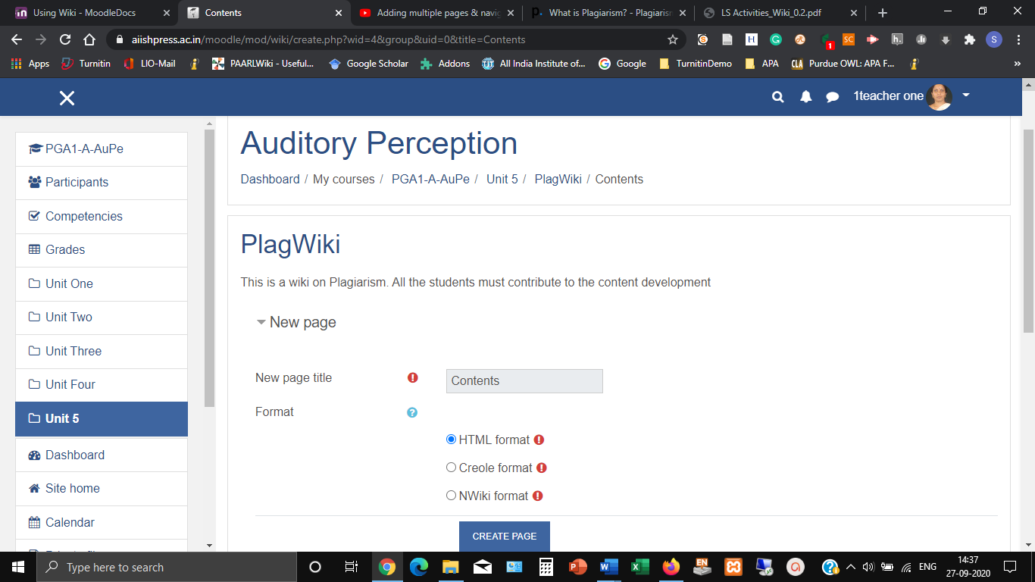

1. The first page we created is ‘Contents’ which will serve as the content page for the Wiki. Enter the names of other pages in the Wiki here: (1) Meaning & Definition, (2) Types of Plagiarism, (3) How to avoid Plagiarism, (4) Plagiarism Detection Tools (5) Plagiarism Vs. Copyright. All these pages should be hyperlinked from the contents. In order to create hyperlinks, the words should be entered in **double square brackets**. Hence, enter the names of pages to be hyperlinked from the content page in square brackets, one in each line. Eg. [[Meaning & Definition]], [[Types of Plagiarism]] etc.
2. Now, the teacher will be able to

Simply type out the word that you would like to use to link to the new page in brackets. This will create a link to a new page in the wiki. For example to create a link to a blank page called: “Definitions” you would type [Definitions].