Academic Integrity Tutorial accessibility document

Retweet module

Use this document as an alternative to the online interactive tutorial

Contents
Academic Integrity Tutorial accessibility document 1
Retweet module 1
Use this document as an alternative to the online interactive tutorial 1
Screen 1 Title slide - Retweet 2
Screen 2 - Introduction 2
Screen 3 – What’s the problem? 3
Screen 4 – Tweeting the problem 4
Screen 5 Skills to avoid Retweet plagiarism 5
Screen 6 – Intentional or accidental? 7
Screen 7 – Conclusion 7
Screen 8 – Additional resources 8
Appendix 10

Screen 1 Title slide - Retweet

Title slide image depicts a bird and the word, “Retweet”

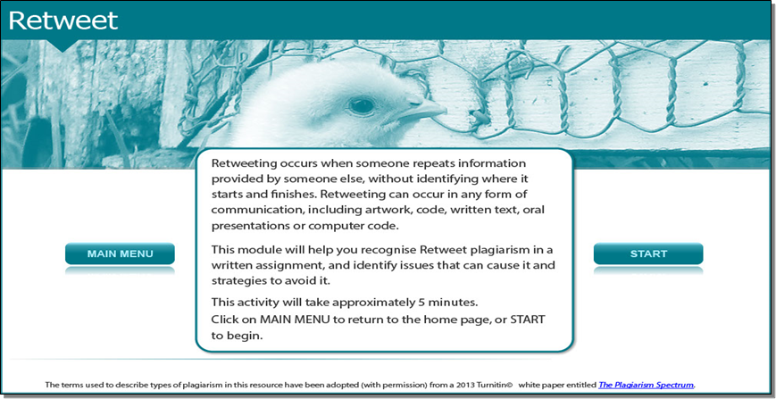

Retweeting occurs when someone repeats information provided by someone else, without identifying where it starts and finishes. Retweeting can occur in any form of communication, including artwork, code, written text, oral presentations or computer code.

This module will help you recognise Retweet plagiarism in a written assignment, and identify issues that can cause it and strategies to avoid it.

This activity will take approximately 5 minutes.

Screen 2 - Introduction

Image shows a female student pointing to an extract from an assignment submission.

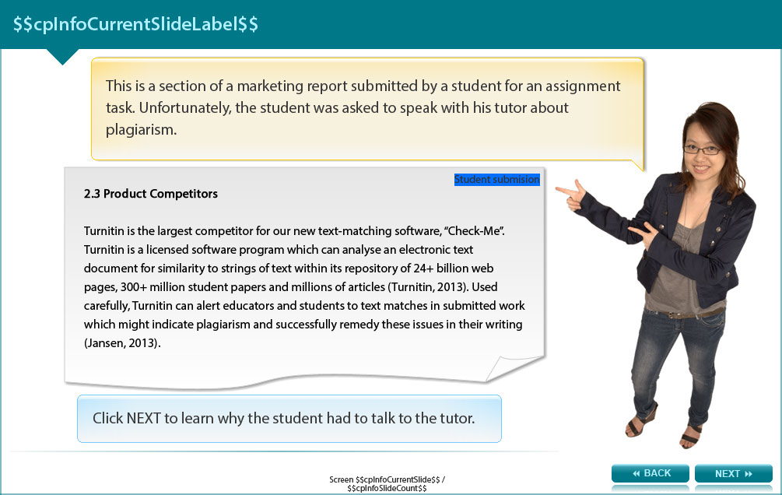

This is a section of a marketing report submitted by a student for an assignment task. Unfortunately, the student was asked to speak with his tutor about plagiarism.

2.3 Product Competitors

Turnitin is the largest competitor for our new text-matching software, “Check-Me”. Turnitin is a licensed software program which can analyse an electronic text document for similarity to strings of text within its repository of 24+ billion web pages, 300+ million student papers and millions of articles (Turnitin, 2013). Used carefully, Turnitin can alert educators and students to text matches in submitted work which might indicate plagiarism and successfully remedy these issues in their writing (Jansen, 2013).

Read on to learn why the student had to talk to the tutor.

Screen 3 – What’s the problem?

Image shows a female student considering part of the marketing student’s submission.

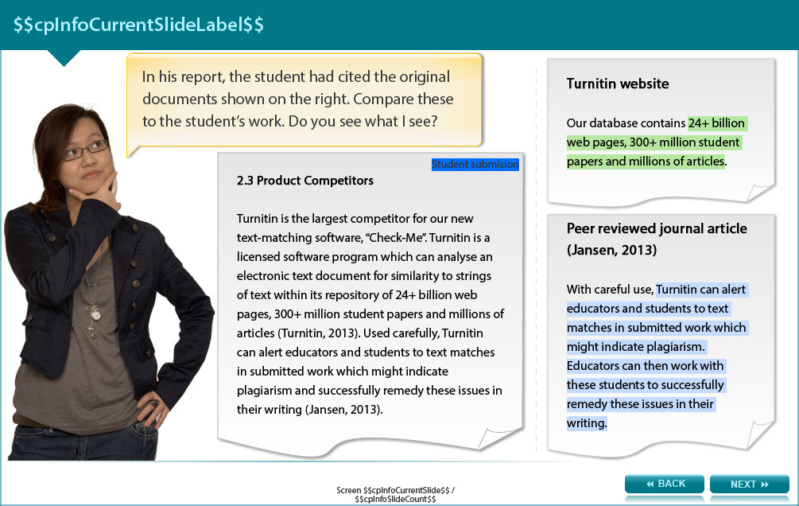

In his report, the student has cited the original documents. Compare the student’s work to the Turnitin website.

This is what the student submitted:

2.3 Product Competitors

Turnitin is the largest competitor for our new text-matching software, “Check-Me”. Turnitin is a licensed software program which can analyse an electronic text document for similarity to strings of text within its repository of 24+ billion web pages, 300+ million student papers and millions of articles (Turnitin, 2013). Used carefully, Turnitin can alert educators and students to text matches in submitted work which might indicate plagiarism and successfully remedy these issues in their writing (Jansen, 2013).

Turnitin website

Our database contains 24+ billion web pages, 300+ million student papers and millions of articles.

Peer reviewed journal article (Jansen, 2013)

With careful use,Turnitin can alert educators and students to text matches in submitted work which might indicate plagiarism. Educators can then work with these students to successfully remedy these issues in their writing.

Screen 4 – Tweeting the problem

The image shows a female student making the thumbs up gesture.

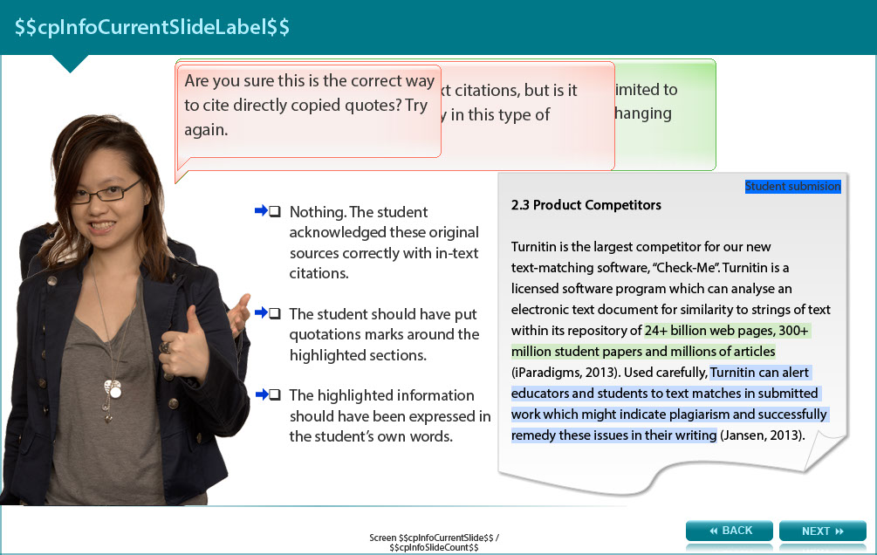

Try answering this question and then check your answer in the Appendix.

What seems to be the problem with the student’s writing? Refer to the previous screen to read the student’s work again.

- Nothing. The student acknowledged these original sources correctly with in-text citations.
- The student should have put quotations marks around the highlighted sections.
- The highlighted information should have been expressed in the student’s own words.

Screen 5 Skills to avoid Retweet plagiarism

Image shows a female student pointing to a list of seven skills.

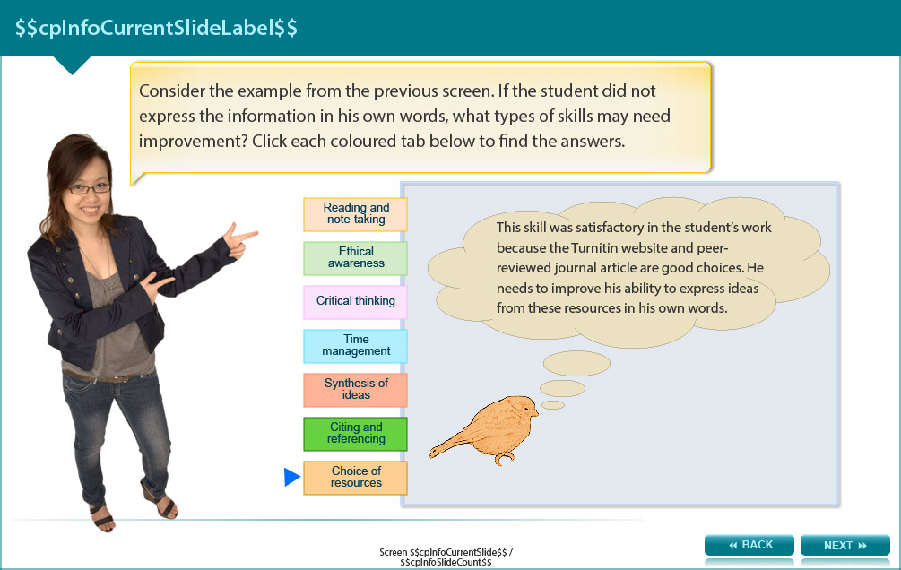

Consider the example from the previous screen. If the student did not express the information in his own words, what types of skills may need improvement?

The user is required to click each of the headings below to read the text.

- Reading and note-taking - Yes Effective reading means thinking about the information, not just copying sections of the original. If the student had taken notes without copying phrases from the original, he would have expressed the information in his own words quite naturally.

- Ethical awareness - True. He may not have been aware that using the exact words of ‘experts’ is inappropriate for academic assignments. Original thoughts and expression are always necessary.

- Critical thinking - Yes. Thinking is required when reading in order to process the new information in relation to other ideas. In this way you develop your own knowledge and understanding and don’t have to rely on the words of others.

- Time management - Absolutely! He might not have left himself enough time to think and take notes in his own words before writing the assignment.

- Synthesis of ideas - This skill was satisfactory in the student’s work because the ideas were sound and logical. He needs to work on skills that will improve his ability to express the ideas in his own words.

- Citing and referencing - This is partly true. He acknowledged the ideas, but the directly copied text was not cited correctly. However, if he had used his own words the citations would be correct.

- Choice of resources - This skill was satisfactory in the student’s work because the Turnitin website and peer- reviewed journal article are good choices. He needs to improve his ability to express ideas from these resources in his own words.

Screen 6 – Intentional or accidental?

Image shows a female student with her hands in a questioning gesture.

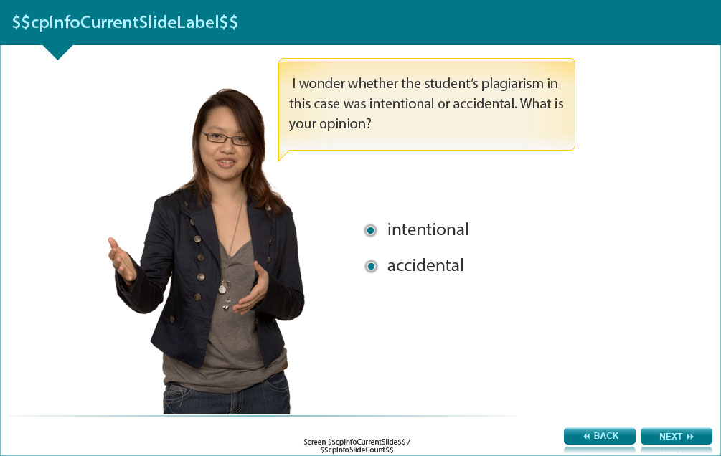

Ask yourself whether the student’s plagiarism in this case was intentional or accidental. Check the appendix for the answer.

- intentional

- accidental

Screen 7 – Conclusion

Image shows a female student holding a sign with four summary points.

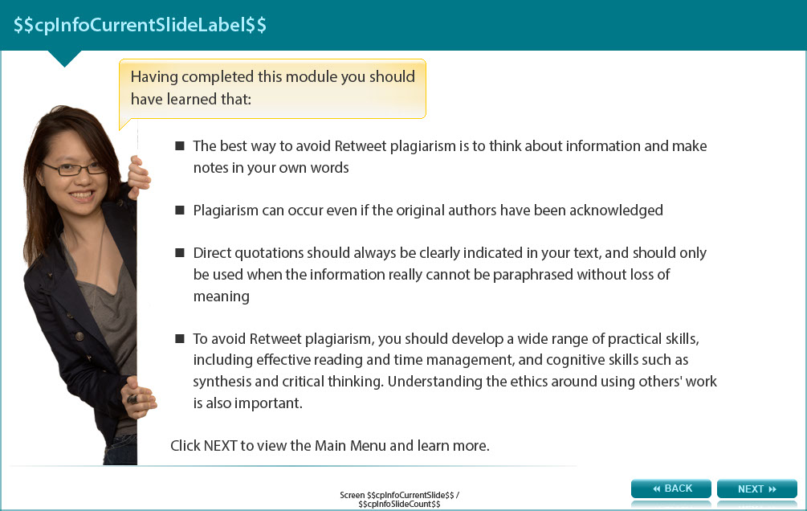

Having completed this module you should have learned that:

- The best way to avoid Retweet plagiarism is to think about information and make notes in your own words

- Plagiarism can occur even if the original authors have been acknowledged

- Direct quotations should always be clearly indicated in your text, and should only be used when the information really cannot be paraphrased without loss of meaning

- To avoid Retweet plagiarism, you should develop a wide range of practical skills, including effective reading and time management, and cognitive skills such as synthesis and critical thinking. Understanding the ethics around using others' work is also important.

Screen 8 – Additional resources

Image shows a range of resources available to help you work with academic integrity

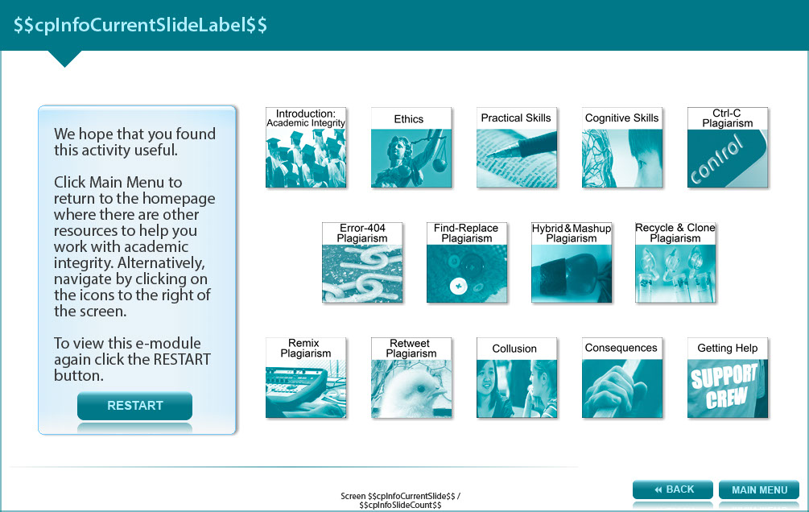

We hope that you found this activity useful.

Click the links below to view other modules in this academic integrity tutorial:

- Introduction: Academic integrity (http://www.monash.edu/rlo/research-writing-assignments/referencing-and-academic-integrity/academic-integrity/introduction)
- Ethics (http://www.monash.edu/rlo/research-writing-assignments/referencing-and-academic-integrity/academic-integrity/ethics)
- Practical skills (http://www.monash.edu/rlo/research-writing-assignments/referencing-and-academic-integrity/academic-integrity/practical-skills)
- Cognitive skills (http://www.monash.edu/rlo/research-writing-assignments/referencing-and-academic-integrity/academic-integrity/cognitive-skills)
- Ctrl-C plagiarism (http://www.monash.edu/rlo/research-writing-assignments/referencing-and-academic-integrity/academic-integrity/ctrl-c)
- Error-404 plagiarism (http://www.monash.edu/rlo/research-writing-assignments/referencing-and-academic-integrity/academic-integrity/error-404)
- Find-Replace plagiarism (http://www.monash.edu/rlo/research-writing-assignments/referencing-and-academic-integrity/academic-integrity/find-and-replace)
- Hybrid & Mashup plagiarism (http://www.monash.edu/rlo/research-writing-assignments/referencing-and-academic-integrity/academic-integrity/hybrid-mashup)
- Recycle & Clone plagiarism (http://www.monash.edu/rlo/research-writing-assignments/referencing-and-academic-integrity/academic-integrity/recycle-and-clone)
- Remix plagiarism (http://www.monash.edu/rlo/research-writing-assignments/referencing-and-academic-integrity/academic-integrity/remix)
- Retweet plagiarism (http://www.monash.edu/rlo/research-writing-assignments/referencing-and-academic-integrity/academic-integrity/retweet)
- Collusion (http://www.monash.edu/rlo/research-writing-assignments/referencing-and-academic-integrity/academic-integrity/collusion)
- Consequences (http://www.monash.edu/rlo/research-writing-assignments/referencing-and-academic-integrity/academic-integrity/consequences)
- Getting help (http://www.monash.edu/rlo/research-writing-assignments/referencing-and-academic-integrity/academic-integrity/getting-help)

Appendix

Screen 4 - Tweeting the problem

- Nothing. The student acknowledged these original sources correctly with in-text citations - Are you sure this is the correct way to cite directly copied quotes? Try again

- The student should have put quotations marks around the highlighted sections - Quotation marks might fix the in-text citations, but is it really OK to use quotes so frequently in this type of academic writing? Think again.

- The highlighted information should have been expressed in the student’s own words - True. For this type of academic writing, quotations should be limited to expressions that could not possibly be paraphrased without changing their meaning.

Screen 6 - Intentional or accidental?

- Intentional - Possibly. If the student had good reading, critical thinking and note-taking skills but left themselves short of time, they may have deliberately ‘cheated’ by copying and pasting ideas together.

- Accidental - Possibly. The student may lack many of the necessary skills to avoid Retweet plagiarism. This can be addressed by developing awareness of these issues and practicing a lot.

