Academic Integrity Online Tutorial – Remix

Remix module

Use this document as an alternative to the online interactive tutorial
Contents
Academic Integrity Online Tutorial – Remix 1
Remix module 1
Use this document as an alternative to the online interactive tutorial 1
Screen 1 – Title slide - Remix 2
Screen 2 - Introduction 2
Screen 3 – Compare the music 3
Screen 4 – Remix activity 4
Screen 5 – Defining remix plagiarism 4
Screen 6 - Remix plagiarism - Intentional or unintentional? 5
Screen 7 - Remix plagiarism - Real consequences! 6
Screen 8 - Remix - written example 7
Screen 9 - Conclusion 8
Screen 10 – Additional Resources 9
Appendix 11

Screen 1 – Title slide - Remix

Title slide showing an image of a keyboard and recording equipment.

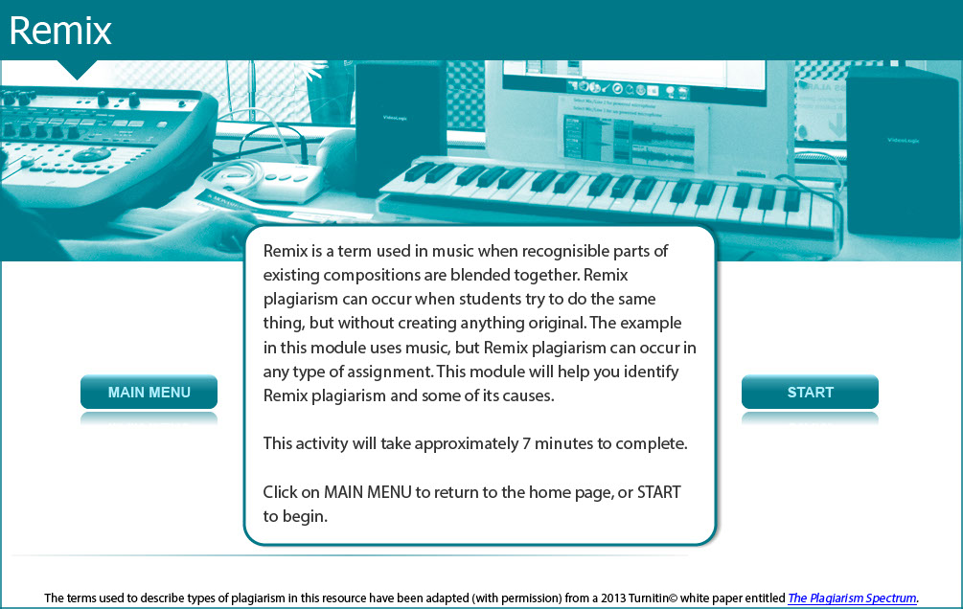

Remix is a term used in music when recognisable parts of existing compositions are blended together.

Remix plagiarism can occur when students try to do the same thing, but without creating anything original. The example in this module uses music, but Remix plagiarism can occur in any type of assignment.

This module will help you identify Remix plagiarism and some of its causes.

This activity will take approximately 7 minutes to complete.

Screen 2 - Introduction

The image shows a female student pointing at a music button.

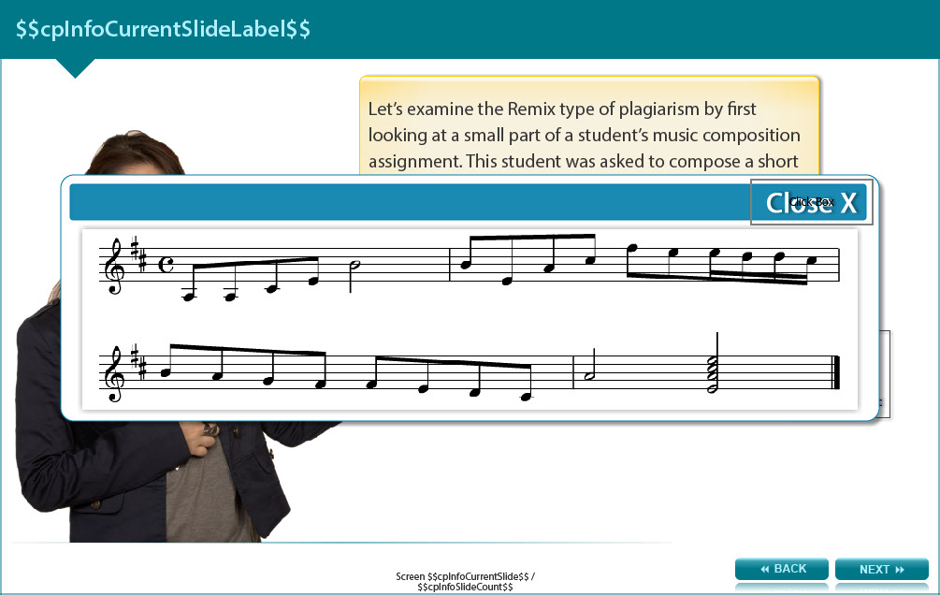

Let’s examine the Remix type of plagiarism by first looking at a small part of a student’s music composition assignment. This student was asked to compose a short original piece of music in a style typical of the Baroque period.

The user clicks the button to play the music and at the same time the musical notes appear on screen. To hear the music, go to screen 2 of the module and click the music button.

Screen 3 – Compare the music

Image shows a girl holding a card with links to a student’s and two composers’ music and part of a student’s score.

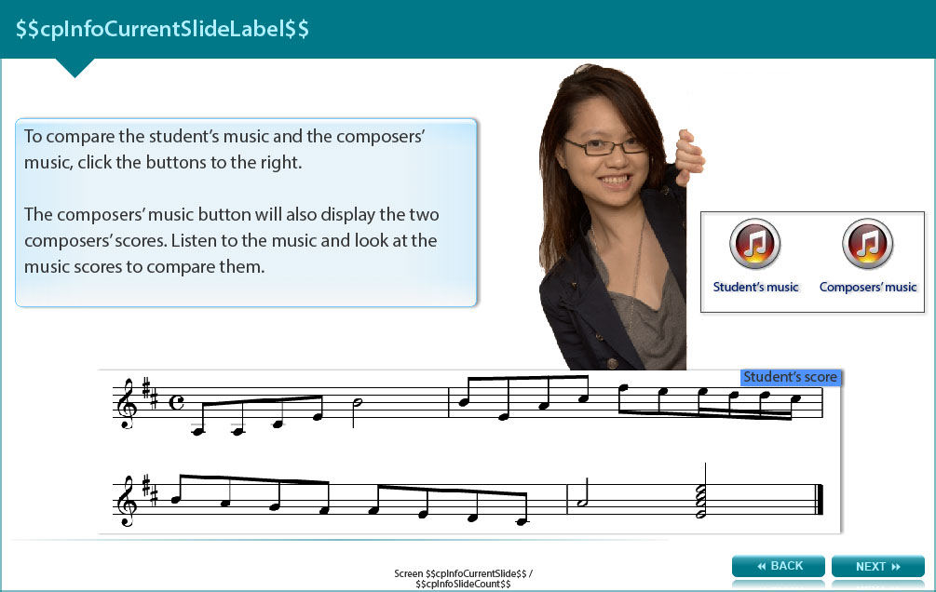
The user clicks the buttons to play the music.

To hear the music, go to screen 3 of the module and click the student’s music button and the composer’s music button. The composer’s music button also displays the two composers’ music scores above the student’s music score.

Can you notice the similarities between the Baroque composers’ scores and the student’s score?

Screen 4 – Remix activity

Image depicts a female student scratching her head and considering descriptions on five music stands.

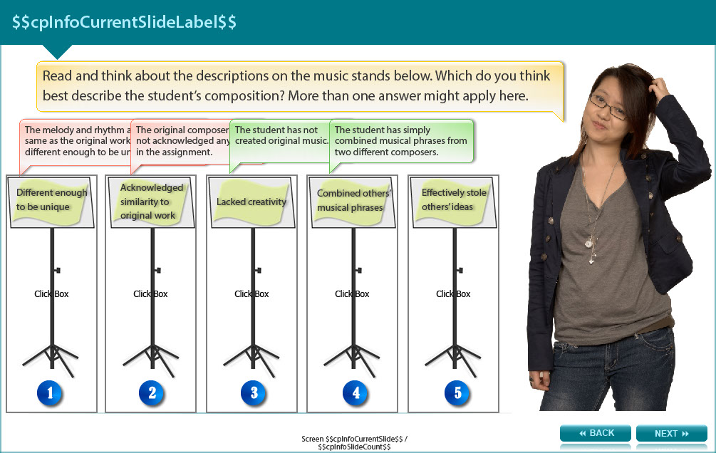

Answer the following question and check the answers in the appendix.

Read and think about the descriptions on the music stands. Which do you think best describe the student’s composition? More than one answer might apply here.

- Different enough to be unique
- Acknowledged similarity to original work
- Lacked creativity
- Combined others’ musical phrases
- Effectively stole others’ ideas

Screen 5 – Defining remix plagiarism

Image shows a female student standing in a thinking posture.
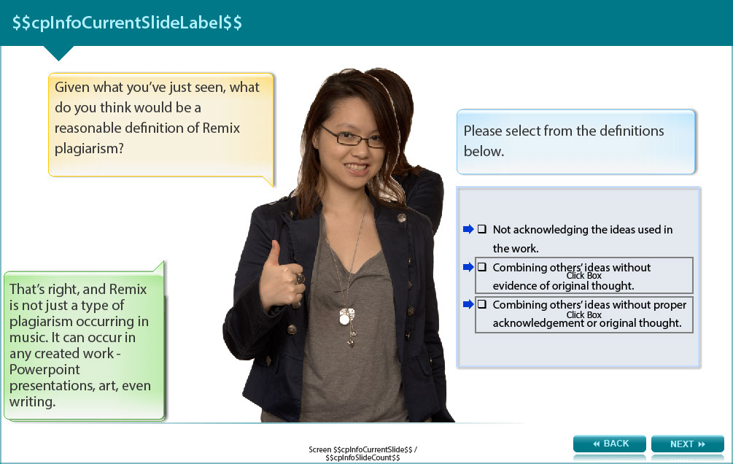

Answer the following question and check the answers in the appendix.

Given what you’ve just seen, what do you think would be a reasonable definition of Remix plagiarism?

- Not acknowledging the ideas used in the work.
- Combining others’ ideas without evidence of original thought.
- Combining others’ ideas without proper acknowledgement or original thought.

Screen 6 - Remix plagiarism - Intentional or unintentional?

Image shows a female student with her hands in a questioning gesture.

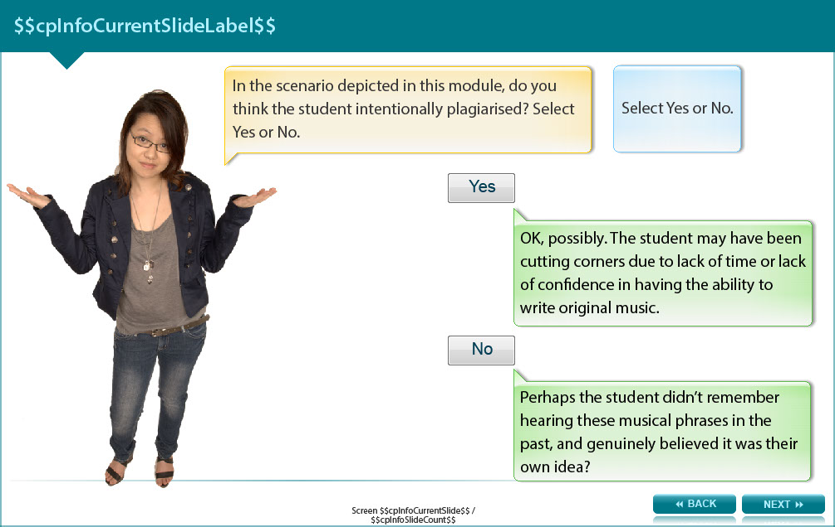
In the scenario depicted in this module, do you think the student intentionally plagiarised?

Choose from the answer options below, then check your choice in the Appendix.

- Yes
- No

Screen 7 - Remix plagiarism - Real consequences!

Image shows a female student pointing to two some text and a newspaper.

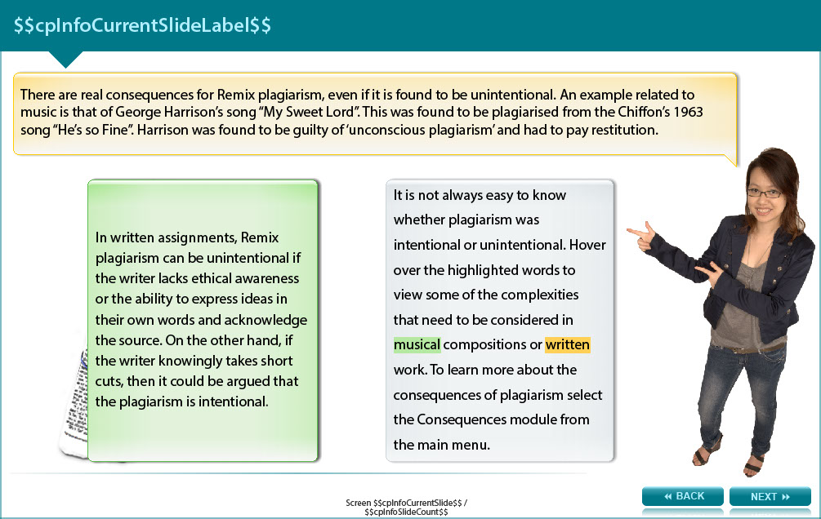

There are real consequences for Remix plagiarism, even if it is found to be unintentional. An example related to music is that of George Harrison’s song “My Sweet Lord”. This was found to be plagiarised from the Chiffon’s 1963 song “He’s so Fine”. Harrison was found to be guilty of ‘unconscious plagiarism’ and had to pay restitution.

It is not always easy to know whether plagiarism was intentional or unintentional.

Complexities that need to be considered in musical compositions or written work include:

- Musical compositions: Use and acknowledgement of musical phrases from another artist does depend on the genre. Jazz, for example, is a form of music based upon improvisation on an existing tune. A skilled jazz musician may never play the tune in the same way each time it is performed. Whilst the tune is based upon an original piece, the value placed on the contribution of the original composer may vary.

- Written work: Remix plagiarism can be unintentional if the writer lacks ethical awareness or the ability to express ideas in their own words and acknowledge the source. On the other hand, if the writer knowingly takes short cuts, then it could be argued that the plagiarism is intentional.

To learn more about the consequences of plagiarism work through the Consequences module.

Screen 8 - Remix - written example

Image shows a female student pointing to an example of a student’s essay.

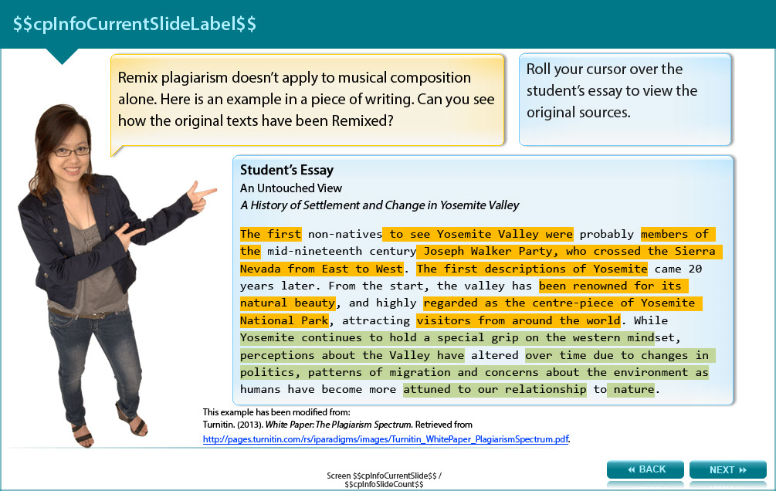

Remix plagiarism doesn’t apply to musical composition alone. Here is an example in a piece of writing. Can you tell where the original texts have been Remixed? (the bold sections relate to original source no.1 and the underlined sections relate to original source no.2)

Part of a student’s essay
An Untouched View: A History of Settlement and Change in Yosemite Valley.
The first non-natives to see Yosemite Valley were probably members of the mid-nineteenth century Joseph Walker Party, who crossed the Sierra Nevada from East to West. The first descriptions of Yosemite came 20 years later. From the start, the valley has been renowned for its natural beauty, and highly regarded as the centre-piece of Yosemite National Park, attracting visitors from around the world. While Yosemite continues to hold a special grip on the western mindset, perceptions about the Valley have altered over time due to changes in politics, patterns of migration and concerns about the environment as humans have become more attuned to our relationship to nature.

Compare it with the original sources.

Original source No. 1
A Natural Setting: A History of Exploration and Settlement in Yosemite Valley
- Since its first discovery by non-indigenous people in the mid-nineteenth century, Yosemite Valley has held a special, even religious, hold on the American conscience because its beauty makes it an incomparable valley and one of the grandest of all special temples of Nature. While Yosemite holds a special grip on the western mind, perceptions about the Valley have evolved over time due to changing politics, migration patterns and environmental concerns as man has become more attuned to his relationship and impact on nature.

Original source No.2
A Short History of America’s National Parks
- The first Europeans to see the Yosemite Valley were most likely to have been members of the Joseph Walker Party, who crossed the Sierra Nevada from East to West before 1840. After the first descriptions of Yosemite appeared two decades later, the valley soon became renowned for its natural beauty. It is now regarded as the centre-piece of Yosemite National Park and attracts visitors from all over the world.

This example has been modified from:
Turnitin. (2013). White Paper: The Plagiarism Spectrum. Retrieved from http://pages.turnitin.com/rs/iparadigms/images/Turnitin_WhitePaper_PlagiarismSpectrum.pdf.

Screen 9 - Conclusion

Image showing a female student with the palms of her hands faced upwards, suggesting understanding and summarising.

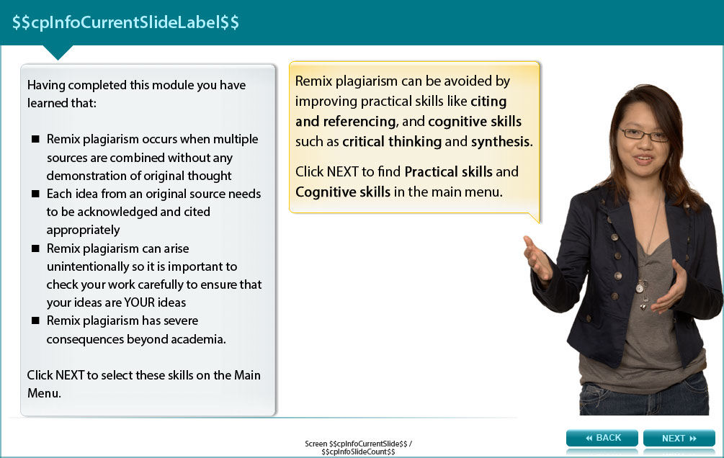

Having completed this module you have learned that:

- Remix plagiarism occurs when multiple sources are combined without any demonstration of original thought
- Each idea from an original source needs to be acknowledged and cited appropriately
- Remix plagiarism can arise unintentionally so it is important to check your work carefully to ensure that your ideas are YOUR ideas
- Remix plagiarism has severe consequences beyond academia.

Remix plagiarism can be avoided by improving practical skills like citing and referencing, and cognitive skills such as critical thinking and synthesis.

Tutorials for these skills are available. Work through the modules titled Practical skills and Cognitive skills.

Screen 10 – Additional Resources

Image shows titles and icons of related resources.



We hope that you found this activity useful.

Click the links below to view other modules in this academic integrity tutorial:

- Introduction: Academic integrity (http://www.monash.edu/rlo/research-writing-assignments/referencing-and-academic-integrity/academic-integrity/introduction)
- Ethics (http://www.monash.edu/rlo/research-writing-assignments/referencing-and-academic-integrity/academic-integrity/ethics)
- Practical skills (http://www.monash.edu/rlo/research-writing-assignments/referencing-and-academic-integrity/academic-integrity/practical-skills)
- Cognitive skills (http://www.monash.edu/rlo/research-writing-assignments/referencing-and-academic-integrity/academic-integrity/cognitive-skills)
- Ctrl-C plagiarism (http://www.monash.edu/rlo/research-writing-assignments/referencing-and-academic-integrity/academic-integrity/ctrl-c)
- Error-404 plagiarism (http://www.monash.edu/rlo/research-writing-assignments/referencing-and-academic-integrity/academic-integrity/error-404)
- Find-Replace plagiarism (http://www.monash.edu/rlo/research-writing-assignments/referencing-and-academic-integrity/academic-integrity/find-and-replace)
- Hybrid & Mashup plagiarism (http://www.monash.edu/rlo/research-writing-assignments/referencing-and-academic-integrity/academic-integrity/hybrid-mashup)
- Recycle & Clone plagiarism (http://www.monash.edu/rlo/research-writing-assignments/referencing-and-academic-integrity/academic-integrity/recycle-and-clone)
- Remix plagiarism (http://www.monash.edu/rlo/research-writing-assignments/referencing-and-academic-integrity/academic-integrity/remix)
- Retweet plagiarism (http://www.monash.edu/rlo/research-writing-assignments/referencing-and-academic-integrity/academic-integrity/retweet)
- Collusion (http://www.monash.edu/rlo/research-writing-assignments/referencing-and-academic-integrity/academic-integrity/collusion)
- Consequences (http://www.monash.edu/rlo/research-writing-assignments/referencing-and-academic-integrity/academic-integrity/consequences)
- Getting help (http://www.monash.edu/rlo/research-writing-assignments/referencing-and-academic-integrity/academic-integrity/getting-help)

Appendix

Screen 4 - Remix activity

Which do you think best describe the student’s composition? More than one answer might apply here.

- Different enough to be unique - The melody and rhythm are essentially the same as the original works, so it’s not different enough to be unique.

- Acknowledged similarity to original work - The original composers were not acknowledged anywhere in the assignment.

- Lacked creativity - The student has not created original music.

- Combined others’ musical phrases - The student has simply combined musical phrases from two different composers.

- Effectively stole others’ ideas - By presenting the work as their own the student claims to be its creator. The work clearly belongs to two other composers.

Screen 5 - Defining remix plagiarism

Given what you’ve just seen, what do you think would be a reasonable definition of Remix plagiarism?

- Not acknowledging the ideas used in the work - True, there is no acknowledgement of others’ ideas, but something else is wrong

- Combining others’ ideas without evidence of original thought - True, there is no original thought in this work, but something else is wrong.

- Combining others’ ideas without proper acknowledgement or original thought - That’s right and Remix is not just a type of plagiarism occurring in music. It can occur in any created work - Powerpoint presentations, art, even writing.
below.

Screen 6 - Remix plagiarism – intentional or unintentional?

- Yes - OK, possibly. The student may have been cutting corners due to lack of time or lack of confidence in having the ability to write original music.

- No - Perhaps the student didn’t remember hearing these musical phrases in the past, and genuinely believed it was their own idea?

