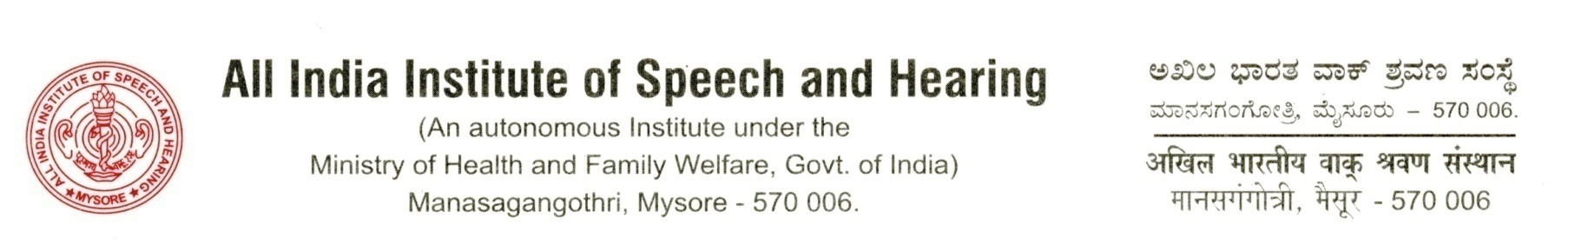

No/SH/MR.5/2018-19 04.09.18

Shri. Rajiv Kumar

Director, Coordination & NCD

Ministry of Health and Family Welfare

Nirman Bhavan

New Delhi 110 108

     Sub: Monthly D.O. to Cabinet Secretary-furnishing information-reg.

     Ref: 1. No. F.No. Z. 20013/1/2014-Cdn-I dated 17.11.14

2. No.V-19019/5/2014-PH-I dated 26.11.14

Dear Sir,

With reference to the above, please find attached the requisite information of this institute, as desired. A copy of the information has also been emailed to [prem.narain68@nic.in](mailto:prem.narain68@nic.in).

Thanking you with regards,

Yours sincerely,

(Sd/)

                      Dr. S.R. Savithri

Director

Copy to:

Shri. Prem Narain

Under Secretary to the Government of India

Ministry of Health and Family Welfare

Nirman Bhavan (Room No. 425 C Wing)

New Delhi-110 108



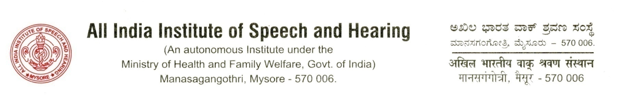

Monthly Report

August- 2018

|  |  |  |
| --- | --- | --- |
| **S.N.** | **Activity/Event** | **Numbers/ Description** |
| 1 | No. of academic programmes offered | **16** |
| 2 | Patient registration-New | **1722** |
| 3 | No. of ongoing research projects   * Intramural * Extramural | **56**  **12** |
| 4 | Other major events/ activities | * The 53rd Institute Annual Day was celebrated on 9th August 2018 during which the Instrument for vestibular testing, Eye Tracking Unit and Renovated Computer Center were inaugurated. * 2nd Internal Hindi Workshop was held on 14th August 2018. * National Seminar on Psychosocial Perspectives of Children and Adolescents with Neuro developmental Disorders was held on 30-31 August 2018. |

(Sd/)

                      Dr. S.R. Savithri

Director

