**अखिल भारतीय वाक श्रवण संस्थान, मैसूरू -06**

**All India Institute of Speech and Hearing, Mysuru-06**

**पुस्तकालय वं सूचना केन्द्र**

**Library and Information Centre**

SH/LIC/SwachhtaSpecia/2022-23 दिनांक/Date 10.06.22

निदेशकको प्रस्तुत/Submitted to the Director.

विषय/Sub: Report on Swachhta Special Campaign 2.0 -reg.

संदर्भ/Ref: संदर्भ/Ref: SH/SAP/Special Campaign 2.0/2022-23 dtd:29.09.22

आदरणीय महोदया/Respected Madam,

With reference to the above, please find attached a report on Swachhta Special Campaign 2.0 carried out in the Library and Information Centre on 6th October 2022.

Thank you,

आपका आभारी/ Yours faithfully

पुस्तकालय वं सूचना अधिकारी/

Library and Information Officer

All India Institute of Speech and Hearing

Library and Information Centre

**Report on Swachhta Special Campaign 2.0**

**6th October 2022**

The Library and Information Centre reviewed and discarded 10 physical files related to the journal subscription and book purchase, and five e-files and folders related to the Institute Annual Report of the previous years. In addition, two areas (sites) of the section were completely cleaned. Space planning was carried out by re-arranging the 2nd floor and 3rd floor sections.

(Sd/)

Library and Information Officer

Before

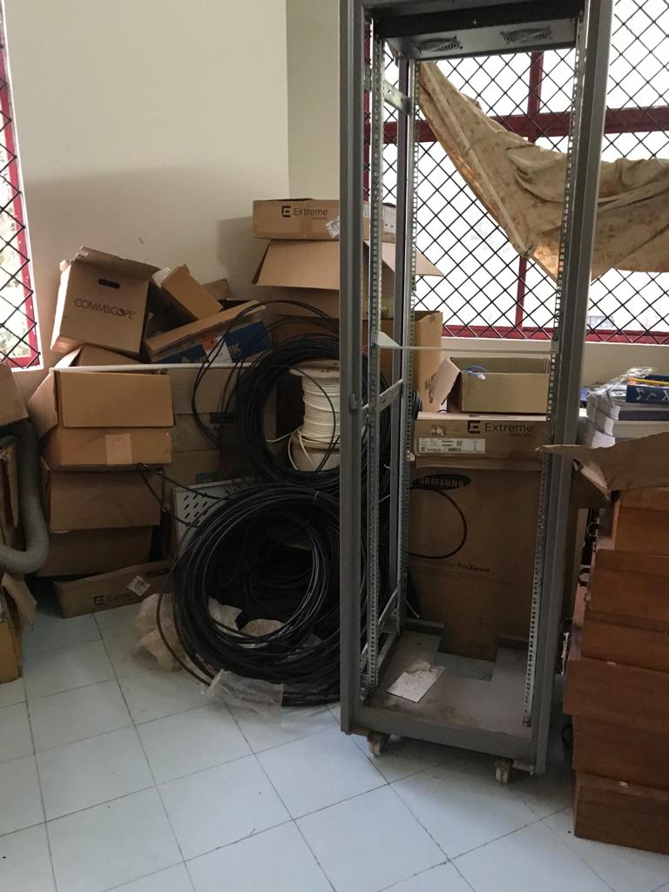

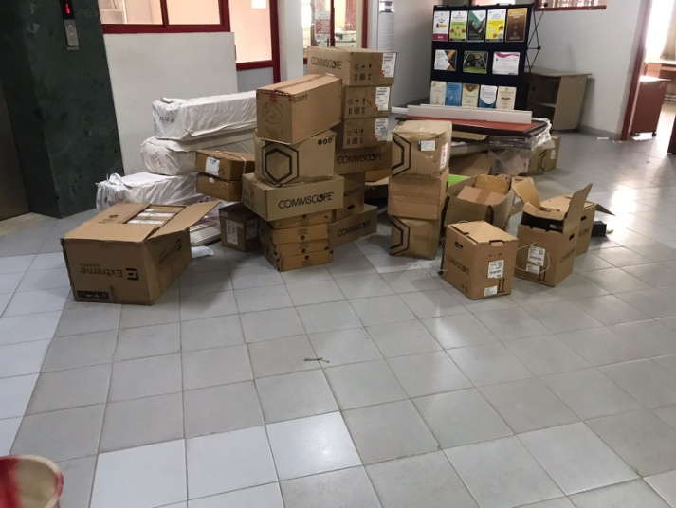

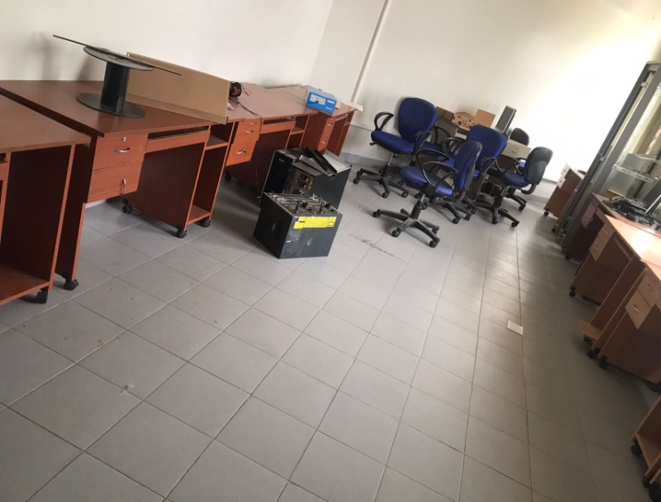

After

