RAJAJI NATIONAL PARK, Uttarakhand

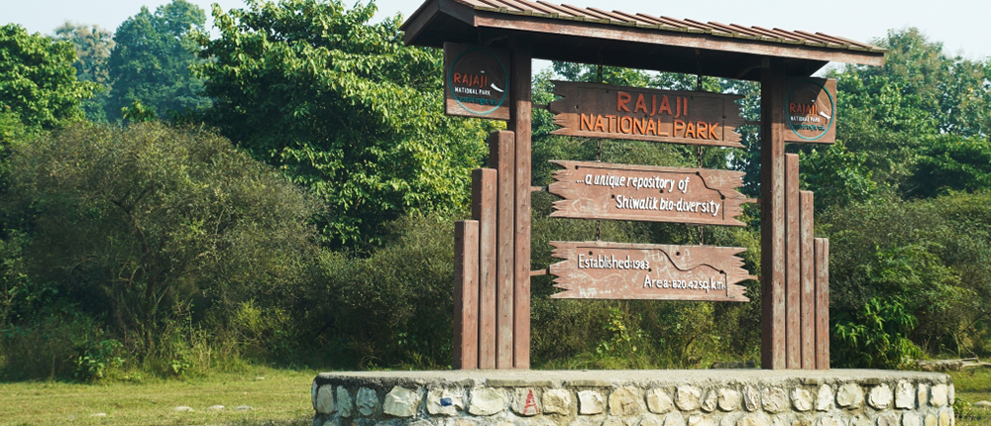

**About the Park**

Rajaji National Park is situated in the state of Uttarakhand. The picturesque beauty and rich biodiversity of the park serve as its major attractions for both nature lovers as well as wildlife enthusiasts. The park has been named after Late Sri C. Rajgopalachari (also known as Rajaji), a famous freedom fighter and first governor general of India . Rajaji National Park of India spreads over an area of 820.42 sq km.

**Biodiversity values**

* A magnificent ecosystem nestling in the Himalayan foot hills
* Possess as many as 23 species of mammals and 315 avifauna species
* Biggest habitat of Asian Elephant and Tiger in Asia

**Flagship species- Asian Elephants**

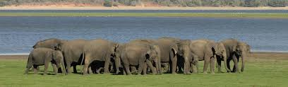

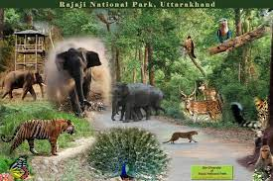

Tiger

Leopard

Hyena

H. Black Bear

Sloth Bear

Ghural

Deer Spp.

Wild boar

Other Species

**Census Figures of 2015/2016**

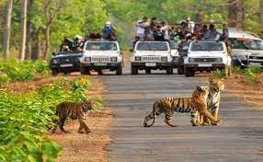**Flora of the Park**

|  |  |  |  |
| --- | --- | --- | --- |
| Species | Male | Female | Total |
| Elephant | 95 | 212 | 307 |
| Tiger | 09 | 12 | 21 |
| Sambar | 947 | 1791 | 1738 |

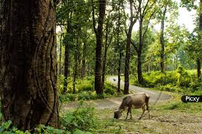

* The forest ecosystem is quite varied and diverse
* Sal (*Shorea robusta*) is the characteristic dominant trees species

Theats

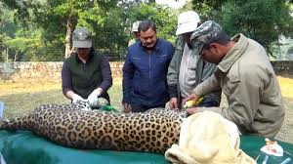

* Human settlements inside Park Area
* Fragmentation of habitat
* Fire incidents
* Man-Animal Conflict