DEVELOPMENT OF MASSIVE OPEN ONLINE COURSES

BASRI AHMEDI, XHEVDET THAQI, RAGMI MUSTAFA, ARTAN DERMAKU, EKREM ALIMI, NYSRET DEMAKU

**Abstract**

*Motivated by a change of generations, an unstable economic situation, and the influence of Information and Communication Technologies, it is becoming increasingly common to find educational models that are already in practice* (Clark and Kwinn 2007)*. The European Higher Education Area (EHEA) has requested an adaptation of the university curriculum with the requirements stated in the Bologna Declaration. Since academic year 2015-2016, the University of Kadri Zeka offers an online teaching platform called "e-Learning" for bachelor's degrees in computer science, education, economics and law. The purpose of this project is to provide a description of the experience of University of Kadri Zeka in the field of online teaching and, more specifically, analyse the results obtained in all subjects from Bachelor of Science in Computer Science. The implementation of this platform is useful but there are also specific difficulties* (Bersin 2004)*. The e-Learning tool allows the teacher to edit any teaching material, format this material in various formats as needed and is placed in the relevant courses where students will have access at any time. In each course created, materials can be placed which continually follow the fulfilment of the obligations for the teaching process. This material is accessible only by students which are following the course, and is also available for the upcoming students enrolled in the same course. This significantly increases teacher-student communication. The following shows the experience of using the e-Learning platform to improve the teaching process in the respective courses at University of Kadri Zeka in Gjilan.*

**Keywords*:*** *e-Learning, implementation,* *teaching process*

**Introduction**

The use of e-Learning as a pilot project in the teaching process at the University of Gjilan has been ongoing for 2 years. The following services have been offered: Syllabi placed in each course, digital literacy placement, placement of lectures in the form of concepts for each week, setting of guidelines for numerical and practical exercises, creation of folders in which students have placed tasks evaluating the knowledge acquired, distance groups communication, information etc. According to the data published in the Higher Education Development Strategy by the Ministry of Education, Science and Technology of Kosovo (2005-2015), the description of the situation in higher education is: the lack of contemporary literature; existing teaching methodology does not support a greater involvement of students in higher education; the existing infrastructure does not support a variety of higher education programmes; the existing infrastructure does not support students with special needs; technological infrastructure for development and evaluation of work in higher education institutions is not used, etc. (Strategjia zhvillimore e Arsimit të Lartë në Kosovë 2005). Students and pedagogical staff in such circumstances seek the opportunity to stimulate these subjects that are more friendly, closer and more accessible, and seek resources after the lecture is finished. ICTs in this context are a very useful tool to provide a whole range of resources for students to achieve better academic performance. This is why at the Faculty of Computer Sciences of the University Kadri Zeka there are open online courses ( Massive Open Online Courses) called e-Learning in order to facilitate and supplement the basic knowledge that students need (Clark and Mayer 2011). The e-Learning platform can be used in the university area to address potential student deficiencies of all courses or to extend the lessons. MOOC consists of an open-air modality in which courses are offered free of charge through educational platforms at universities. The aim is to disseminate knowledge in a way that is accessible and useful for all students.

In order for any on-line platform to be considered MOOC, it must meet the following requirements:

• Its structure should be learning-oriented, with a range of tests or assessments that can assess the knowledge gained.

• The number of enrolled must be, in principle, unlimited or at least much higher than the number on a face-to-face basis.

• The materials are online and available for the users of the platform.

• Materials must be accessible free of charge.

There are different types of MOOC, depending on the objectives, methodologies and expected results. In this context, and thanks to the cooperation of the Faculty of Computer Science of UKZ, we present a version of MOOC (Moodle), the purpose of which is an additional tool which qualitatively influences the realisation of various study programmes for all departments at the University of Kadri Zeka in Gjilan.

**Methodology**

The platform (http://www.usht.us/course/category.php?id=48) provides good structural organisation. The first category is the University and then within the subcategories are Departments, Years, and Courses. In each year of the corresponding department, a course with the corresponding name is created. Each course is divided into 15 weeks. In each week, significant amounts of information, teaching materials of varying lengths and different formats such as text, photos, sound, video can be placed. Students' homework, various additional materials, selected exercises, etc. can also be included. Also in one or more weeks of the course, a folder can be created in which students themselves can set homework and tasks where the professor can more easily check and evaluate them. These services allow access also for students who for various reasons have not attended classes. In this way, it is intended to motivate students to study the subject by offering them online materials and making them part of a class "as if they had participated" in real time (King, Robinson and Vickers 2014). Using a survey for the e-Learning platform efficiency with students and teachers in all departments, resulted in an outcome that gives an advantage to the electronic teaching especially in the field of online lectures, limitation of the teaching material, valuation, results, communication etc. During the academic year 2016/2017, all these actions have also been tracked using the e-Learning system itself while being logged in as an Administrator. Thus, using surveys with concrete questions and direct monitoring through the e-Learning system, an evaluation of the online learning system in the University of Kadri Zeka – Gjilan was conducted (Fig.7).

The main page of the e-Learning site is depicted in Fig. 1.

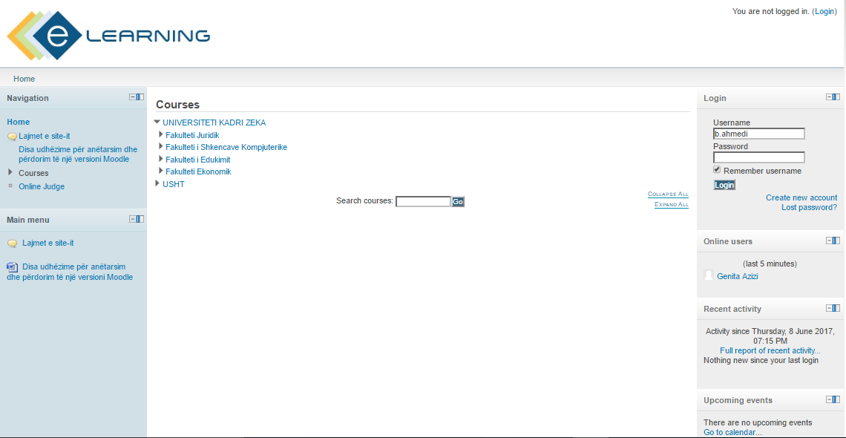

**Figure 1.** *The e-Learning platform*

Access to e-Learning have previously joined students and professors. Access is granted through a username and password. The number of users has been growing continuously. Currently, there are 1427 out of 3000 potential users. The login window is depicted in Fig. 2.

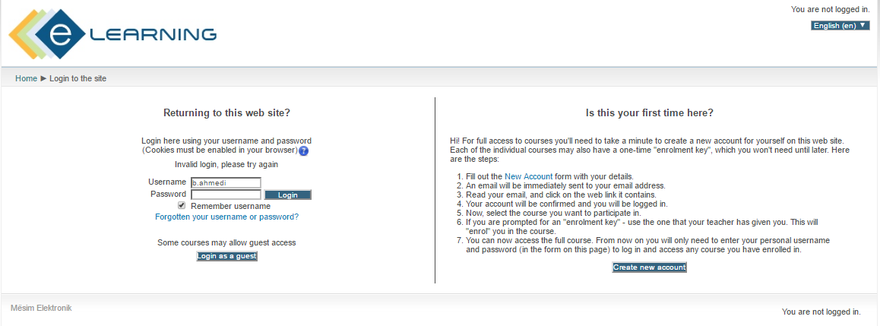

**Figure 2.** *Login for e-Learning*

In addition to content materials, in an e-Learning course, there are more than twenty exercises that have been described in detail, allowing students to use critical thinking skills to solve problems by using the right tools and technological resources. The fact that students have at their disposal multiple exercises at a time, with answers provided facilitates studying (Fig. 3).

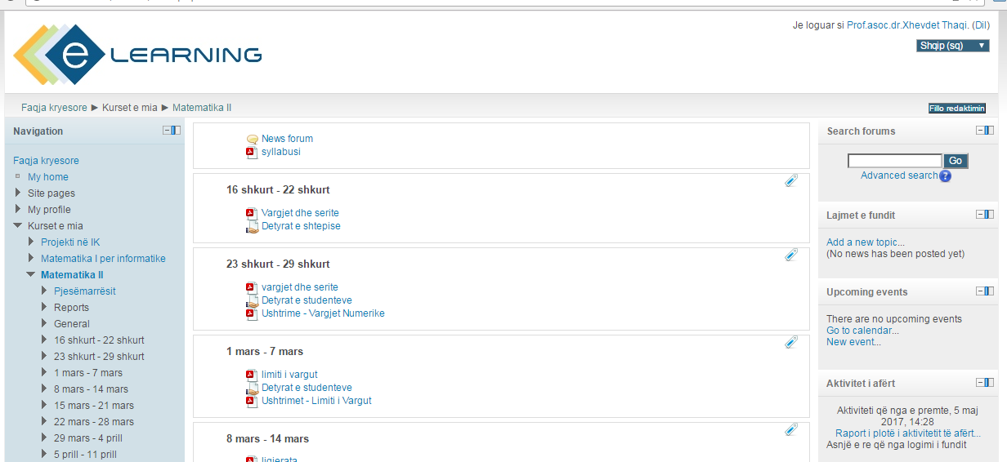

**Figure 3.** *View of the course in e-Learning*

In each and every course, teachers periodically comment on different aspects related to the learning and assessment of student work. Teachers can perform graphical analysis of texts, exercises, discussions, group work, demonstration and interpretation, study of ideas, creative materials, and individual research. The goal is to bring the subject closer to students by reducing the distance between theory and the real world, seeking to awaken their interest and motivation towards learning. In fact, in January 2016, the main MOOC platform at UKZ (http://uni-gjilan.net/) started to operate with several courses. Then the number of courses was increased and today it is 70 (Fig. 4).

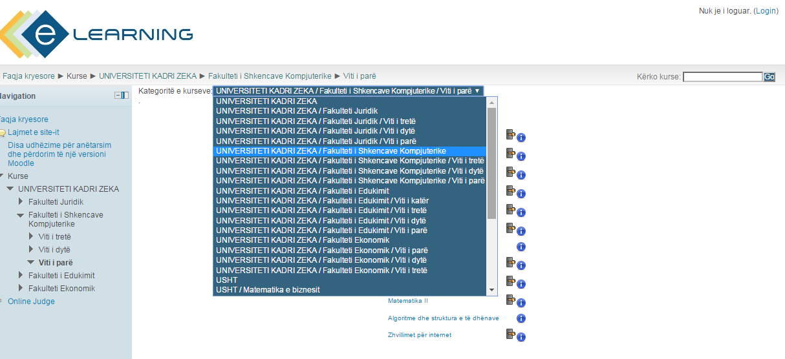

**Figure 4.** *Distribution of courses by department*

In the e-Learning platform are placed 90 out of 150 subjects of study programmes at UKZ. From 1st of October 2017, using e-Learning in the teaching process will be obligatory for each subject for each study programme at the University. The structure of the e-Learning platform is as follows:

* An introductory module, which has materials, presentations and a test of previous knowledge.
* 13-14 content modules, each of which has the lesson in the form of a PDF, a ppt explaining the subject, a test and a forum.
* A midterm and final exam (Fig. 5)

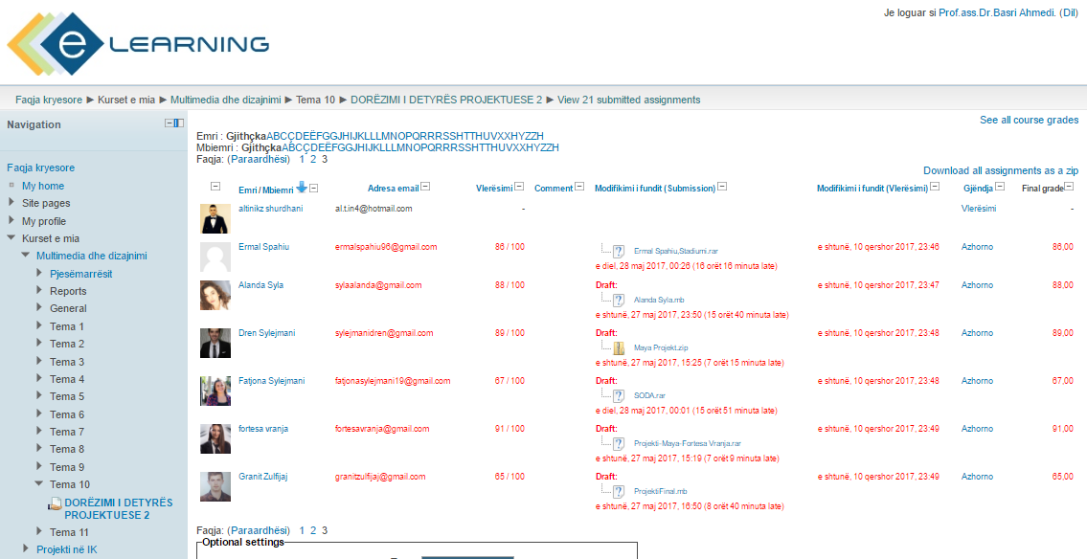

**Figure 5.** *Assessments and final exam*

**Results**

The number of participants currently using the e-Learning platform is 1427. The participants are students at one of the four departments at University of Kadri Zeka in Gjilan. Indeed, we can see that all students in the department of Computer Science are using e-Learning while most of the students from the department of Education and Economics are using it, but fewer students are using it from the Law Faculty. The results obtained from the platform usage have been very positive. Thus, if we compare the e-Learning logins between the academic year 2015/16 and the academic year 2016/17 (winter semester), we can see a large increase which is a good indicator for the implementation of e-Learning at UKZ.

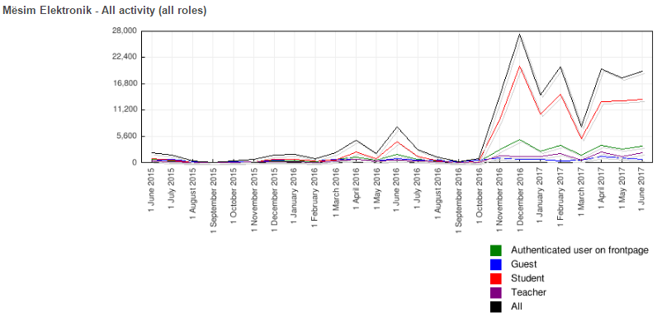

**Figure 6.** *User activity on the e-Learning platform from 2015/2016 to 2016/2017*

The course is divided into 15 weeks and includes: curriculum and explanation literature, teaching methodology, use of the e-Learning platform, then two periodic assessment tests and 13 other topics that make up the subject. Of logins in June 2016 with a maximum number of 7521 and in December 2017 there are 27389 logins. From this we can see that we have an increase of 264% in logins for December 2017 compared to June 2016 (Fig. 6).

**Conclusions**

The incorporation of the e-Learning platform at University of Kadri Zeka has entailed a significant increase in the number of participants in the courses. In addition to increasing numbers, the fact that participants come from different social and economic backgrounds has presented a challenge for standardising courses in a way that is comfortable for most users. Changes related to evaluation and teaching process has provided very good results in attending courses and assessments. The opinion expressed by 880 surveyed students shows that 81% are satisfied with the help provided by e-Learning platform. (Fig. 7).

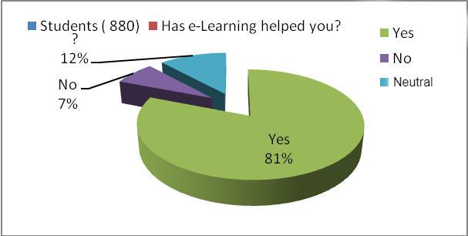

**Figure 7.** *Survey results of UKZ students*

Units with a lower degree of success than expected were discovered, so it is possible to consider how different solutions are required to increase the success rate.

The main advantages of using the e-Learning platform for students based on a survey are:

- Access to an open educational practice. Students can register for free in our e-Learning platform.

- The ability to access the written materials at any time, and other materials for explaining the subject.

- Access to exercises solved in detail, which facilitate the understanding of theoretical content.

- Test performance that allows teachers to control the assimilation of the material.

- A forum in which students can make an inquiry, resolve peer issues, or communicate with the teacher. All this occurs in an environment with more than 1427 registered students, coming from different countries. The forum represents a very convenient instrument to promote collaborative activity between students and teachers.

- Leaving the modules open from the beginning to the end of the course facilitates the possibility that each person, given personal circumstances, can work at their own pace. In this way, autonomous and responsible work is promoted along with student decision-making in a virtual environment.

- The possibility of using innovative methodologies in teaching, such as the flipped classroom.

The e-Learning platform, meanwhile, also includes some of the advantages shown for MOOC, such as:

- Access to videos, materials, exercises, etc.

- Possibility of reading, writing and editing of contents as needed.

With these advantages we have been able to stimulate the student's interest and motivation to learn, which is reflected in a better rate of learning success. As the next step, one development line we are exploring is to adapt content to a wider range of University education centres for all study programmes, and all departments at University of Kadri Zeka in Gjilan.

# References

Bersin, Josh. 2004. *The Blended Learning Book.* San Francisco: Pfeiffer.

Clark, Ruth Colvin, and Ann Kwinn. 2007. *The new Virtual Classroom:Evidence-based Guidlines for Synchronous e-Learning.* Pfeiffer.

Clark, Ruth Colvin, and Richard E. Mayer. 2011. *e-Learning and the Scieence of Instruction.* San Francisco: Pfeiffer.

King, Carolyn, Andrew Robinson, and James Vickers. 2014. "Online eduacation: Targeted MOOC captivates students." *Nature,505.*

2005. *Strategjia zhvillimore e Arsimit të Lartë në Kosovë.* Prishtinë: Ministry of Education Science and Technology of Kosovo.